

Why One Might Aught to Cook with Cannabis…

We turn our heads, but we all know that the inhalation of burnt plant matter is not healthy. However, the profoundly obliging properties of medicinal marijuana are irrefutable and historically integrated into many cultures. Currently the most common means of ingestion remains the act of smoking.

The compounds in marijuana that deliver medicinal results are broken down differently in flame than they are in digestion, and can be much more effective when they have not been burnt. Not to mention that each exhale contains plenty more THC that will never be absorbed by the body. This scenario may also leave one’s environment with a distinctive aroma, which one may or may not desire for various reasons.

Edibles produce a different feeling, experience, and effect than smoking. In addition to lasting longer, some agree that the focused sensations are more bodily and less cerebral.

When cooking with cannabis the variability of flavors is endless, and one can enjoy a tasty treat and one’s medicine simultaneously. Win, win!

By no means is anyone required to choose between eating and smoking. Should one choose to do both, knock one-self out!

For Consideration:

Each Marijuana plant is different. Even the same strain of plant, or a plant cloned from its predecessor will produce differently under varying conditions. Additionally, every person responds differently to its consumption. That said… “Ya don’t know what you’re gonna get ‘til ya got it.” So it is important to use one’s best judgment when deciphering between high grade and low grade cannabis. Approach recipes conservatively and work one’s way up in potency.

* For medicinal use only. Remember, marijuana is still illegal unless prescribed.

* Do not drive nor operate heavy machinery while medicated. This is not cool at all.

* Doses are estimated, don’t overdo it. Start out small as it can take 30 to 75 minutes for effects to kick in. If you eat too much you will regret it, so don’t say we didn’t tell you so.

* By reading this book you deem the authors and Roachclip.com are not held liable for any of the results of your culinary experiments including, but not limited to, harm caused by your debaucherous activities.

Side Effects Include:

Euphoria, feelings of wellbeing, irresistible laughter, the urge to share love and joy, delicious flavor enhancement and an exaggerated ability to process the observation of good music.
CANNABIS RECIPES

The Adulterated Basics:
- CannaButter & CannaOil
- Weed Milk & Weed Half & Half
- Keef

Breakfast:
1. Blueberry Corn Cakes
2. Crazy Crunchy French Toast
3. Ham & Cheese Quiche
4. Choco-Oatmeal w/ the Fixin’s
5. Spiked Sausage Patties

Appetizers / Side Dishes:
1. Grilled Asparagus w/ Hollandaise
2. Bomb Ass Red Potato Salad
3. Dizzy Deviled Eggs
4. Rock Star Mushroom Risotto
5. Chillaxin’ Chilli

Main Course:
- Pasta Bolognaise
- The Bestest Butternut Squash Casserole Ever
- Cauliflower Enchilada
- Vegetable Stir-fry
- Eggplant Pharmesan

Sweets / Deserts:
- Honey Raisin Bran Muffin
- Rasta Rice Pudding
- Pumpkin Pie
- Dark Chocolate Peanut Butter Chip Cookie
- Biggity-Baked Apples

Beverages / Misc:
- Orange Dreamcicle Smoothie
- Peanutbutter Banana Nutella Shake
- Madicated Iced Coffee Late
- Spiked Salad Dressing
- Hummus

CannaButter & Oil

------------------------------------------------------------------------------------
Ingredients:

- 1 oz. coarsely ground Medicinal Marijuana.
- 1 Lb. unsalted butter or shortning, Or 16 Oz Oil (Recommended: Olive, Sunflower, or Peanut)
- Water
----------------------------------------------------------------------------------------------------------------------

Directions:

Pour ground marijuana into a Crock-pot and add water, at a ratio of 3 parts water to 1 part plant matter.

Simmer for 6 hours on Low heat, stirring occasionally.

Once the plant matter has settled more toward the bottom, add a half cup of cold water and stir in the butter or oil.

Simmer stirring often. Do not allow the mixture to reach a boil. Continue to simmer on low for an additional 3 hours. The plant matter should settle to the bottom again when it is properly cooked.

First strain the mixture through a rice strainer. Add boiling water to the strainer to extract more THC. Using a ricer (looks like a garlic press), claim the remaining butter or oil from the plant matter left in the strainer. Next strain it through a finer mesh sifter. This can also be done by pressing the remaining plant matter through cheese cloth.

Let it cool, for a few min. Place a lid on it, and then bring it down close to room temp before refrigerating or freezing it.

For butter, Refrigerate for 3 days. Then collect the solid butter that has settled on top of the water. Scrape off the layer of cream and minor bits of plant matter that bordered the water layer. It can be used for other baking.

For Oil, freeze it for 1-2 days, then separate the water and oil with a knife and place the oil into a container to bring back to room temp. If you need your oil right away, you may be able to see the separation of the water & oil as the mixture cools. Ladle most of the oil off the top gently and place it into a separate container. Otherwise, use a turkey baster to suck the water out from the bottom layer and dispose of the water, leaving just the oil.

Weed Milk or Weed Half & Half

------------------------------------------------------------------------------------
Ingredients:

- 1/8 Oz of High Grade Medical Marijuana (or 1/4 Oz of low grade)-finely ground
- Half gallon of whole milk or 1 quart of half & half cream
----------------------------------------------------------------------------------------------------------------------

Directions:

Line the crock-pot with a Slow Roaster brand bag to reduce clean-up mess (optional).

Pour the milk or half & half into the lined crock-pot. Then pour in the finely ground medical marijuana. Stir vigorously, cook on medium-high heat for one hour.

Turn the heat down to low and let simmer for another 6-8 hours, stirring occasionally.

Turn off heat and let cool for a little while before straining.

Strain out the plant matter. Using a cheese cloth works well.

Next, let the concoction cool to nearly room temperature, then refrigerate until you are ready to use it.

NOTE: 1 -3 fluid oz of weed milk in your coffee or cereal is a great dose for the day! Or ½-1 ½ oz of half and half will have the same potency.

Blueberry Corn Cakes

------------------------------------------------------------------------------------

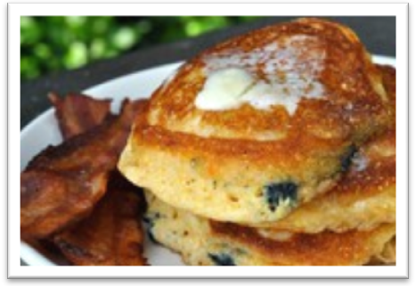
Ingredients:

2/3 cup all-purpose flour
- 2/3 cup fine stone-ground cornmeal
- 2 tablespoons sugar
- 1 1/2 teaspoons baking powder
- 1 1/2 teaspoons baking soda
- 1/2 teaspoon salt
- 1 cup buttermilk
- 1 large egg, separated
- 1 cup blueberries
- 2 tablespoons marijuana vegetable oil
- Softened unsalted Canna-butter and warm pure maple syrup, for serving
----------------------------------------------------------------------------------------------------------------------

Directions:

In a medium bowl, whisk together the flour, cornmeal, sugar, baking powder, baking soda and salt.
In a small bowl, whisk the buttermilk with the egg yolk.
In a medium bowl, beat the egg white until firm peaks form. Add the buttermilk mixture to the dry ingredients and stir gently with a wooden spoon until evenly moistened; there will still be some lumps. Fold in the beaten egg white and then the blueberries.

Heat a large cast-iron skillet. Add 1 tablespoon of the canna-oil, and when it is hot, spoon 1/4 cup of the batter into the skillet for each pancake. Cook over moderate heat until browned on the bottom and bubbles will appear on the surface, about 3 minutes. Flip and cook until browned on the second side, about 2 minutes longer. Add 1 more tablespoon of canna-oil to pan when the first has been used up. Use up to 3.

Keep the pancakes warm in a low oven while you continue with the remaining oil and batter. Serve the pancakes with canna-butter and maple syrup. Use desired about of canna-butter in a light spread over top of corncakes. Serves up to 6.

Crazy Crunchy French Toast

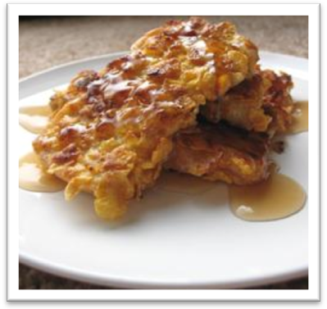
------------------------------------------------------------------------------------

Ingredients:

- 3 eggs
- 1/4 cup weed milk
- 2 cups cereal with granola, crushed
(Recommend Honey Bunches of Oats)
- 4 slices bread, cut into thirds
- 1 tablespoon Canna-butter
---------------------------------------------------------

Directions:

Whisk the eggs and weed milk together in a bowl.
Spread the crushed cereal onto a plate. Dip each
piece of bread into the egg mixture and then press gently into the cereal, turning to coat completely. Place the breadsticks onto a plate while breading the rest; do not stack.

Melt the canna-butter in a skillet over medium heat; cook the coated breadsticks in the melted butter until golden, about 4 minutes each side.

Ham & Cheese Quiche


------------------------------------------------------------------------------------
Ingredients:

- 4 eggs
- 1/2 Lb diced ham
- 2 cups marijuana infused half-and-half cream
- 1/8 teaspoon salt
- 1/4 teaspoon white pepper
- 1/8 teaspoon ground nutmeg
- 4 ounces Jarlsberg cheese, shredded
- 2 ounces mozzarella cheese, shredded
- 1 (9 inch) unbaked pie shell

----------------------------------------------------------------------------------------------------------------------

Directions:

Preheat oven to 425 degrees F (220 degrees C).

In a large bowl, whisk together eggs and half-and-half. Season it with salt, white pepper, and nutmeg. Place shredded Jarlsberg and mozzarella in the pie shell. Pour egg mixture over cheese. Add diced ham.

Bake in preheated oven for 15 minutes. Reduce heat to 350 degrees F (175 degrees C), and bake for 25 minutes, or until crust is golden and filling is set. Allow to set 5 to 10 minutes before serving. Serves 6-8.

Chaco-Oatmeal with the Super Fixin’s
------------------------------------------------------------------------------------

Ingredients:

- 1 tablespoon canna-butter
- 1 cup steel cut oats
- 3 cups boiling water
- 1/2 cup whole weed milk
- 1/4 cup low-fat buttermilk
- 1 tablespoon brown sugar
- 1/4 teaspoon mixed spices( cinnamon, nutmeg)
- 1 scoop chocolate Slimfast shake mix
- 1/4 cup chopped cashews
- 1/8 cup raisins
----------------------------------------------------------------------------------------------------------------------

Directions:
In a large saucepot, melt the canna-butter and add the oats. Stir for 2 minutes to toast. Add the boiling water and reduce heat to a simmer. Keep at a low simmer for 25 minutes, without stirring.
Combine the weed milk, Slimfast shake mix, and the buttermilk with the oatmeal. Stir gently to combine and cook for an additional 10 minutes. Spoon into a serving bowl and top with more weed milk until desired potency, or regular milk. Add brown sugar, and spices as well as any “fixins”, such as chopped cashews and raisins. Serves 4.
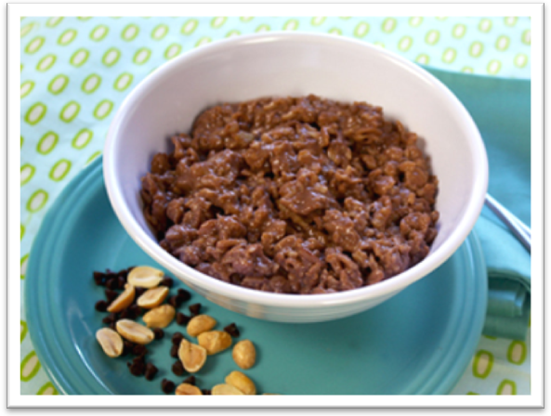
Spiked Breakfast Sausage
------------------------------------------------------------------------------------
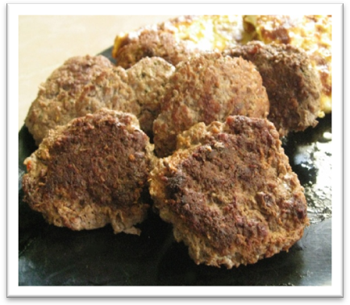
Ingredients:

- 1 roll (16 Oz) of Jimmy Dean Breakfast sausage
- 1 gram keef
---------------------------------------------------

Directions:

Mix keef evenly with the raw sausage meat. Form into 6-8 patties.

Cook the patties in a frying pan, lid on, on low until cooked thoroughly. Avoid frying the meat on high or potency will be lost.

Recommend serving this delightful meat dish with some spiked scrambled eggs and cut fruit on the side.

Grilled Asparagus w/ Hollandaise
------------------------------------------------------------------------------------

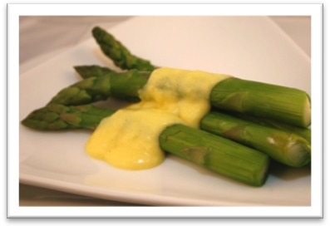
Ingredients:

- 2 tablespoons white-wine or tarragon vinegar or fresh lemon juice
- 4 tablespoons boiling water
- 3 large egg yolks
- 1/2 cup unsalted canna-butter
- 1/4 teaspoon cayenne
- 1/2 teaspoon salt
- 1 Lb of Asparagus

---------------------------------------------------------------------------------------------------------------------------------
Directions:
Melt the butter and keep it warm. Heat the vinegar or lemon juice until just warmed. Have small saucepan with boiling water and a measuring tablespoon ready.
Place the top of a double boiler over (not in) hot water. (This means the bottom of the top of the double boiler sound not make contact with the water heating in the bottom half of the double boiler.)
Place the egg yolks in the top of a double boiler and whisk until they begin to thicken. Now add 1 tablespoon of the boiling water. Continue to beat the sauce until it begins to thicken. Repeat with the remaining water, one tablespoon at a time, beating the mixture after each addition.
Meanwhile, grill or pan fry asparagus until desired tenderness.
Now add the warmed vinegar or lemon juice. Remove the double boiler from the heat. Beat the sauce briskly with a wire whisk. Continue to beat the mixture as you slowly pour in the melted butter. Add the salt and cayenne and beat the sauce until it is thick. Serve immediately overtop the asparagus. Serves 8.

Bomb-Ass Red Potato Salad
------------------------------------------------------------------------------------
Ingredients:
- 2 pounds small red potatoes, uniform size as much as possible
- 2 tablespoons plus 1 1/2 teaspoons coarse salt
- 2 tablespoons red wine vinegar
- 1 tablespoon Dijon mustard
- 1/3 cup cannabis infused extra-virgin olive oil
- 2 shallots chopped fine (about 1/3 cup)
- 10 Green Olives without pimento, sliced into thin rounds (about 1/4 cup)
- 2 tablespoons coarsely chopped fresh flat-leaf parsley
- Freshly ground pepper to taste
----------------------------------------------------------------------------------------------------------------------
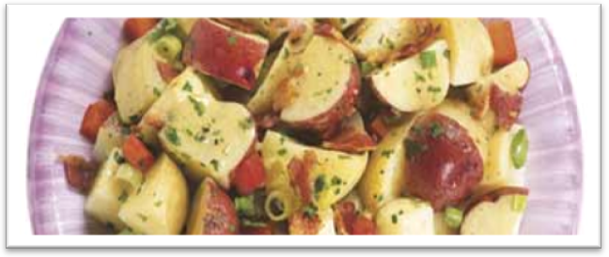

Directions:
Cover potatoes with water in a medium saucepan. Add 2 tablespoons salt. Bring to a boil; reduce heat, and simmer until tender, 11 to 15 minutes. Drain potatoes, reserving 1 tablespoon cooking water. Halve the potatoes; quarter them if they're large.
Make the vinaigrette: Whisk together vinegar, mustard, and reserved cooking water in a small bowl. Gradually add canna-oil, whisking until emulsified. Transfer potatoes to a medium bowl, and drizzle with vinaigrette. Add shallots, green olives, parsley, remaining 1 &1/2 teaspoons salt, and the pepper. Using a large spatula, gently stir to combine. Serves about 10.

Dizzy Cheezy-Baco Deviled Eggs

-------------------------------------------------------------------------------------------------------------

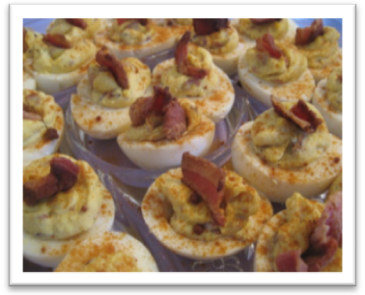
Ingredients:

- 12 eggs
- 1/2 cup mayonnaise
- 4 slices bacon
- 2 tablespoons finely shredded Cheddar cheese
- 1 tablespoon mustard
- 1 gram keef

-------------------------------------------------------------------------------------------------------------

Directions:

Place eggs in a saucepan, and cover with cold water. Bring water to a boil and immediately remove from heat. Cover, and let eggs stand in hot water for 10 to 12 minutes. Remove from hot water, and cool. To cool more quickly, rinse eggs under cold running water.

Meanwhile, place bacon in a large, deep skillet. Cook over medium-high heat until evenly brown. Alternatively, wrap bacon in paper towels and cook in the microwave for about 1 minute per slice. Crumble and set aside.

Peel the hard-cooked eggs, and cut in half lengthwise. Remove yolks to a small bowl. Mash egg yolks with mayonnaise, crumbled bacon and cheese. Stir in mustard and keef. Fill egg white halves with the yolk mixture and refrigerate until serving. Original Recipe Yield 24 deviled eggs. Serves 24.

Rock Star Mushroom Risotto

------------------------------------------------------------------------------------

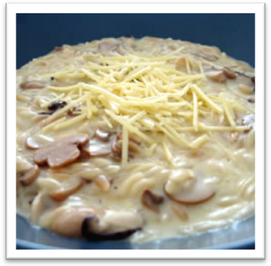
Ingredients:
- 8 cups chicken broth, low sodium
- 3 tablespoons Canna-oil (Olive), divided
- 1 onion, diced, divided
- 2 garlic cloves, minced, divided
- 1 pound fresh Portobello and
Crimini mushrooms, sliced
- 2 bay leaves
- 2 tablespoons fresh thyme, chopped
- 2 tablespoons fresh Italian parsley, chopped
- 2 tablespoons canna-butter
- Salt and pepper
- 1 tablespoon Truffle oil
- 1-ounce dried porcini mushrooms, wiped of
grit
- 2 cups Arborio Rice
- 1/2 cup dry white wine
- 1/2 cup fresh parmesan cheese, grated
- Fresh Italian parsley, for garnish
-------------------------------------------------------------------------------------------------------------
Directions:
Heat the chicken broth in a medium saucepan and keep warm over low heat.
Heat 1 tablespoon of oil in a large skillet over medium heat. Add 1/2 onion and 1 clove garlic, cook, stirring, until translucent, about 5 minutes. Add the fresh mushrooms, herbs and canna-butter. Sauté for 3 to 5 minutes until lightly browned and season with salt and pepper. Drizzle in truffle oil then add the dried porcini mushrooms which were reconstituted in1 cup of warm chicken broth. Season again with salt and fresh cracked pepper. Sauté 1 minute then remove from heat and set aside.
Coat a saucepan with remaining 2 tablespoons of canna-oil. Sauté the remaining 1/2 onion and garlic clove. Try to keep the heat medium/low to preserve potency. Add the rice and stir quickly until it is well-coated and opaque, 1 minute. This step cooks the starchy coating and prevents the grains from sticking. Stir in wine and cook until it is nearly all evaporated.
Now, with a ladle, add 1 cup of the warm broth and cook, stirring, until the rice has absorbed the liquid. Add the remaining broth, 1 cup at a time. Continue to cook and stir, allowing the rice to absorb each addition of broth before adding more. The risotto should be slightly firm and creamy, not mushy. Transfer the mushrooms to the rice mixture. Stir in Parmesan cheese and cook briefly until melted. Top with a drizzle of truffle oil and chopped parsley before serving. Serves 16.

Chillaxin’ Chili
------------------------------------------------------------------------------------

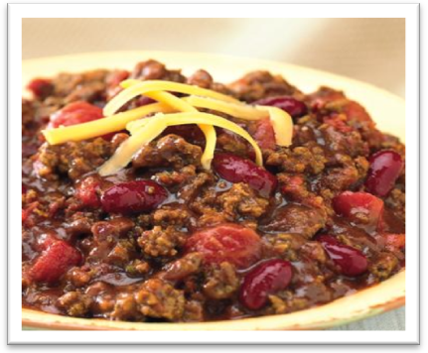
Ingredients:

- ¼ cup CannaOil (Olive)
- 1 package ground pork
- 1 package ground sirloin
- 2 cans red kidney beans
- 1 can of pinto beans, no seasonings
- 2 cans stewed tomatoes
- ½ yellow onion
- ¾ packet of Lowry’s Chili Seasoning
- Shredded cheese

-------------------------------------------------------------------------------------------------------------

Directions:

Add finely chopped onion to a stock pot and brown it in 1 tablespoon of CannaOil. Cook over low heat until onions are soft. Add ground meat and the rest of the “Olive” oil browning the meat on medium heat. Next add all cans of beans and stewed tomatoes (do not drain). Simmer on low for 1 hour. Add Shredded cheese. Serves 5-6.

Pasta Bolognese
------------------------------------------------------------------------------------

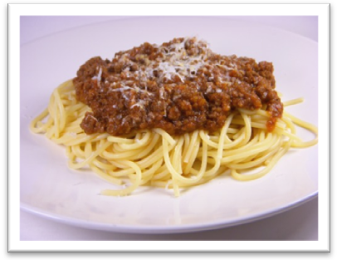
Ingredients:

- 3/4 pound whole-wheat pasta
(fettuccini is recommended)
- 1 tablespoon Cannabis olive oil
- 1 small onion finely chopped (about 1 cup)
- 2 carrots, finely chopped (about 1/2 cup)
- 2 stalks celery, finely chopped
(about 1/2 cup)
- 8 ounces mushrooms, finely chopped
- 3 cloves garlic, minced
- 1 pound lean ground beef (90 to 95 percent lean)
- 2 tablespoons fresh thyme leaves or 2 teaspoons dried
- 2 (14 1/2-ounce) can no salt added diced tomatoes with juice
- 1/2 cup low-sodium chicken broth
- 1/4 cup weed whole milk
- Salt and pepper to taste
- 1/4 cup grated Parmesan
-------------------------------------------------------------------------------------------------------------

Directions:

Set a large pot of water on the stove to boil, and cook the fettuccini according to the directions on the box.
In the meantime, heat the canna-oil in a large skillet over a medium heat. Add the onion, carrots, and celery and cook for 5 minutes, stirring occasionally. Add the mushrooms and cook for 5 minutes more, stirring occasionally. Add the garlic, ground beef, and thyme and cook until the meat is browned, breaking it up into small pieces as it cooks, about 5 minutes.
Stir in the tomatoes and broth and cook for 5 minutes, or until sauce is thickened. Stir in the weed milk and cook for 1 minute more. Season with salt and pepper.
When the pasta is done, drain it, put it back in the pasta pot, add the sauce and stir the sauce and pasta together. Put into serving bowls and top with Parmesan cheese. Serves 5 people.

The Bestest Butternut Squash Casserole Ever
------------------------------------------------------------------------------------

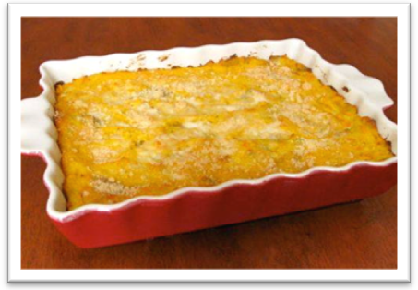
Ingredients:

- 1 small Vidalia onion,
chopped (about 3/4 cup)
- Water
- 2 pounds yellow squash,
cut into 1/2 to 1-inch cubes
- Kosher salt and freshly cracked black
pepper
- 1 cup good quality mayonnaise
- 1 1/2 cups grated Gruyere cheese
- 1 1/4 cups crushed butter crackers, divided
- 1 gram keef

-------------------------------------------------------------------------------------------------------------

Directions:

Preheat the oven to 350 degrees F*
In a heated skillet, cook the onions, adding a little water to prevent them from burning. Cook until lightly brown, adding more water, if needed. Add the squash, season with salt and pepper, to taste, and cook until the squash is tender, about 8 to 10 minutes. Remove the skillet from the heat and stir in the mayonnaise, keef, 1 cup of the cheese and 1 cup of the crumbled crackers. Pour the mixture into a 1 1/2-quart baking dish. Sprinkle with remaining cheese and top with remaining 1/4 cup of butter crackers. Bake until the casserole is bubbly around edges, about 25 minutes. Remove the casserole from the oven and serve hot. Serves 20.

Cauliflower Enchiladas
------------------------------------------------------------------------------------

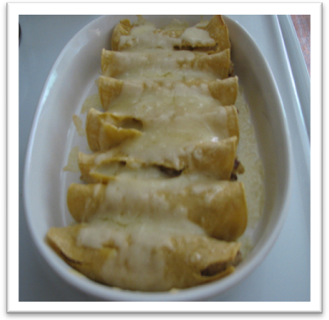
Ingredients:

3 heads Cauliflower (Cut into small florets)

Reserve ½ cups florets to garnish the top

4 cups Water

1 tablespoon Salt

1 cup Weed Milk

2 ½ cups Dried, Instant Potato Flakes

½ teaspoon Ground Cumin

4 cups Shredded Jack Cheese

16 Corn Tortillas

4 cups Prepared Enchilada Sauce

-------------------------------------------------------------------------------------------------------------

Directions:

To make the filling:

Bring the cauliflower to a boil in 4 cups of water. Add salt and cook until tender. Drain cauliflower and place in a medium bowl. Add milk, instant potatoes and cumin, and mix until well incorporated. Add 3 cups of shredded cheese, and mix well. Adjust seasoning if necessary and let cool.

Next, warm tortillas slightly (this will help them to be more pliable). Prepare a 9x12 baking dish by spraying with non-stick spray. Ladle ½ cup Enchilada sauce into pan and spread on the bottom of the pan. In center of tortilla, place 3 tablespoons of cauliflower, mix and roll. Place in prepared dish and repeat using all of the tortillas and filling. Drizzle remaining sauce to cover the rolled tortillas. Sprinkle remaining cheese over the top and scatter the reserved cauliflower florets over the cheese. Bake, covered for 20 minutes at 375 degrees. Remove foil and bake an additional 10 minutes. Let stand 5 minutes before serving. Contains 8 servings.
Vegetable Stir Fry
----------------------------------------------------------------------------------------------
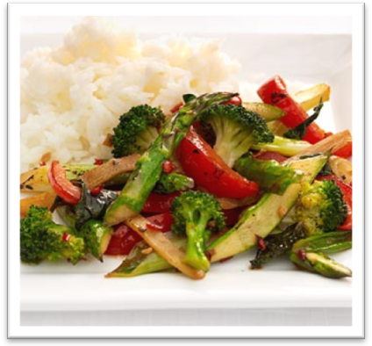
Ingredients:

- Asparagus – 200gms bundle
- Broccoli – 2 medium
- 1/3 of 1 Red Bell Pepper
- Snow Peas – 1 cup
- Spring Onions – 5 medium with long
stalks
- Canna Butter – 1 tablespoon
- Pepper – 2 to 3 teaspoons
- Salt – 1 teaspoon
- Garlic paste – 1 tablespoon

-------------------------------------------------------------------------------------------------------------

Directions:

Chop veggies and keep aside: Broccoli is chopped into 1 inch florets. Hold the asparagus stalks from the two ends and bend. It will split at the point that separates the hard stalk from the soft bud part. We want the soft part. Spring onions are chopped coarsely. Snow peas don’t need to be chopped. Cut bell pepper into thin slices.

Fill a pan with water and throw the broccoli and asparagus in for a 4 minute boil.
After the 4 minutes boil, add 1 tablespoon butter to a fresh pan. This pan will be on a medium flame. After the butter has melted completely, add the garlic paste and mix well.

Toss the broccoli and asparagus in and stir for 2 minutes. Add the spring onions and snow peas.
Add salt and pepper over the veggies and stir for 1 more minute. Contains 4 servings.

Eggplant PHARMesan
------------------------------------------------------------------------------------
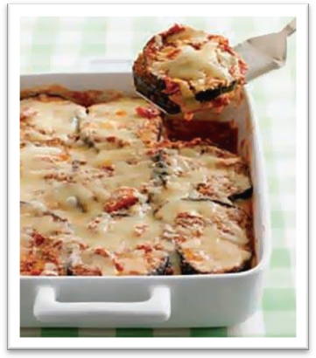
Ingredients:

- 2 eggplants (2 1/2 lb), cut in 1/2-in.- thick rounds
- Nonstick spray
- 1/2 tsp freshly ground pepper
- 1 jar (26 oz) marinara sauce (about 3 cups)
- 1 1/2 cups (6 oz) shredded part-skim mozzarella
- 1/2 cup grated Parmesan
- ½ gram keef

-------------------------------------------------------------------------------------------------------------

Directions:

You’ll need a broiler pan with rack and a shallow 3-qt baking dish. Heat broiler.

Place half the eggplant on broiler rack; evenly coat with nonstick spray then sprinkle with half the pepper. Broil 4 inches from heat for 4 to 8 minutes per side until lightly browned and tender. Repeat with remaining eggplant and pepper.

Heat oven to 350°F

Premix keef into marinara sauce evenly. Spread 1/2 cup marinara sauce in baking dish. Line with 1/2 the eggplant. Spoon on 1 1/4 cups sauce; top with 1 cup mozzarella, then remaining eggplant, sauce and mozzarella. Sprinkle with Parmesan; cover with foil.

Bake 45 minutes or until bubbly. Let cool 15 minutes before serving. Plan ahead: You can assemble through Step 4 and refrigerate up to 1 day before baking. If you bake it straight from the fridge, add about 10 minutes to baking time. Serves 10.
Raisin Bran Buzz Muffin
------------------------------------------------------------------------------------
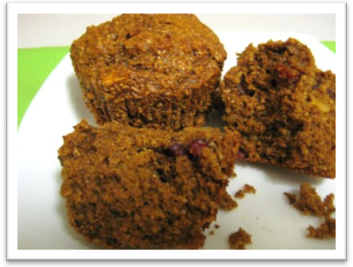
Ingredients:

- 1 1/4 cups all-purpose flour
- 1 tablespoon baking powder
- 1/4 teaspoon salt
- 2 cups Raisin Bran cereal
- 1 cup weed Milk
- 1/2 cup unsweetened applesauce
- 1 egg, slightly beaten
- 1/3 cup brown sugar, firmly packed
- 2 tablespoons Canna-butter, melted
- Honey
-------------------------------------------------------------------------------------------------------------

Directions:

Preheat oven to 400 degrees F

Prepare a muffin tin with paper liners or by spraying with cooking spray.

Mix flour, baking powder, salt, cereal and weed milk in large bowl; let stand 3 minutes.
Stir in egg, applesauce, sugar and canna-butter; stir just until moistened (batter will be lumpy).

Fill each muffin cup 2/3 full. Bake at 400 degrees F for 20 minutes or until golden brown. Use a toothpick to test if they are done. Push the toothpick in the middle of one of the muffins and if it comes out dry then they are done. Drizzle with honey & serve. Serves 6.

Rasta Rice Pudding
------------------------------------------------------------------------------------
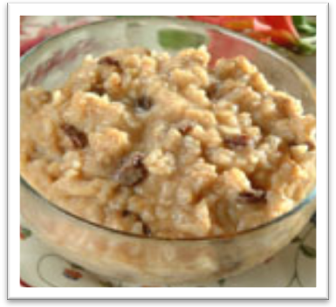
Ingredients:

- 3 beaten eggs
- 1 1/2 c. weed milk
- 1/2 c. sugar
- 1 tsp. pure vanilla extract
- 1 c. medium or long-grain rice, cooked
- 1/2 c. brown raisins
- 1/4 tsp. ground cinnamon

-------------------------------------------------------------------------------------------------------------

Directions:

Preheat oven to 325°F.
Before you start, choose a 1 1/2 to 2 quart casserole dish and set it in a roasting pan. Pour in enough water so that the casserole dish is sitting in about an inch of water. Pour the water into a pan and bring it to a boil.
While the water is heating up, in a mixing bowl, combine eggs, weed milk, sugar and vanilla. Beat until well-mixed. Add rice and raisins. Pour into the ungreased 1.5 to 2 quart casserole and sprinkle the cinnamon on top. Place the casserole inside the roasting pan and add the boiling water to the outside pan.
Bake for about an hour, stirring well after 30 minutes. Bake until a knife inserted in the middle comes out clean. Serve warm, room temperature or cold. Contains 6 servings.

Peppy Pumpkin Pie
------------------------------------------------------------------------------------

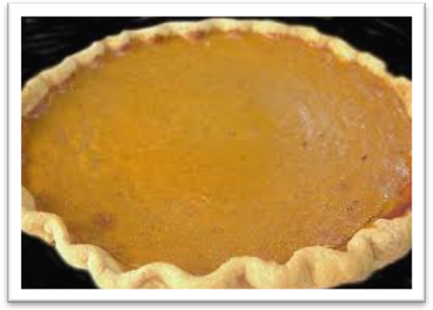
Ingredients:

For Pastry:
- 1 1/2 cups flour
- 1/4 tsp. salt
- 1/2 cup cannabis infused vegetable shortening, chilled
For Filling:
- 2 whole eggs; lightly beaten
- 1 16-oz can solid pack pumpkin
- 3/4 cup Sugar
- 1/2 teaspoon Salt
- 1 teaspoon Cinnamon
- 1/2 teaspoon Ginger
- 1/4 teaspoon Cloves
- 1 1/2 cups Evaporated milk
---------------------------------------------------------------------------------------------------------

Directions:

For pastry: Sift flour and salt together in a large bowl. Cut in canna-shortening with a pastry cutter or 2 knives until mixture resembles coarse meal. Add up to 5 tbsp. ice water as needed, 1 tbsp. at a time, mixing until dough holds together. Form into a ball, wrap in plastic wrap, and refrigerate for 1 hour.

Preheat oven and cookie sheet to 375 degrees F

For Filling: Remove one pie crust from refrigerator. In a blender, combine the items in the filling in the order given. Place pie crust on preheated cookie sheet, near center of oven. Working quickly, pour filling into pie crust. Bake for 70 minutes or until knife inserted in center comes out clean. Cool & Garnish with whipped cream, if desired. Contains 10 servings.

Double Chocolate Peanut Butter Chip Cookies
------------------------------------------------------------------------------------
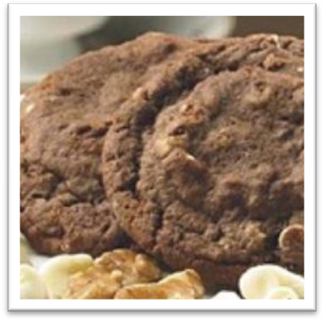
Ingredients:

- 1 cup canna-butter
- 1 cup white sugar
- 3/4 cup brown sugar
- 2 eggs
- 1 teaspoon vanilla
- 1 3/4 cups flour
- 1 1/4 cups cocoa powder
- 2 teaspoons baking soda
- 1/2 teaspoon salt
- 2 cups peanut butter chips

-------------------------------------------------------------------------------------------------------------

Directions:

Preheat oven to 350 degrees.

In a large bowl, cream together the butter, brown sugar and white sugar until light and fluffy. Add eggs one at a time, then add vanilla.

In another bowl, combine the flour, cocoa, salt and baking soda and gradually add to the creamed mixture. Fold in chocolate chips. Drop by rounded spoonfuls onto the prepared cookie sheet.

Bake for 10-12 minutes until puffy but still soft. Allow cookies to cool on baking sheet for 5 minutes before removing to a wire rack to cool completely.
Serves 18

Biggity-Baked Apples
------------------------------------------------------------------------------------
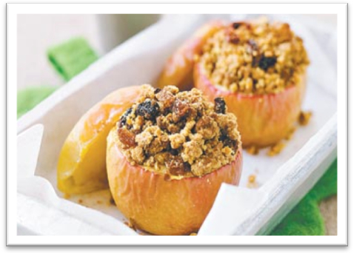
Ingredients:

- 6 Anzac or ginger snap cookies
- 1/4 cup plain flour
- 1/4 teaspoon cinnamon
- 2 tbsp unsalted chopped Canna
butter
- 1/8 cup sultanas
- 4 pink lady apples

-------------------------------------------------------------------------------------------------------------

Directions:

Preheat oven to 170°C. Place cookies in a food processor and process until they resemble rough crumbs. Alternatively, place cookies in a plastic bag, seal and pound lightly with a rolling pin until crushed.
Transfer crumbs to a clean bowl. Add flour, cinnamon and butter, rubbing the mixture between your fingers until it resembles coarse crumbs. Add sultanas and combine.
Slice the top quarter off apples, and reserve the 'lids'. Use a small sharp knife or apple corer to remove the core from each apple. Discard core. Place the apples on a baking tray - along with the 'lids' - lined with non-stick baking paper. Spoon the cookie mixture evenly among the center of each cored apple. Bake for 20 minutes or until apples are tender and the crumble is golden brown. Serve with custard or cream. Serves 4 people.

Orange Dreamcicle Smoothie
------------------------------------------------------------------------------------

Ingredients:

- 1 ½ Cups Cushed Ice
- ¾ Cups Weed Milk
- 1 Cup Orange Sherbet
- ½ cup Frozen Yogurt (not tart)
- 1 Oz Vanilla Coffee Creamer
- Orange Juice

-----------------------------------------------------------------------

Directions:

Combine ingredients in a blender, let ‘er rip... and get ripped. Serves 3 people.

Peanut Butter Banana Nutella Shake
------------------------------------------------------------------------------------

Directions:

- 1 ½ Cups Crushed Ice
- ¾ Cups Weed Milk
- ½ Cup Crunchy Peanut Butter
- ¼ cup Nutella
- 1 Ripe Banana
- 1 Cup Frozen Yogurt (not tart)
- 1 Oz Vanilla Coffee Creamer
------------------------------------------------------------------

Directions:

Combine all the ingredients in a blender. Blend until consistent. Serves 3 people.

Medicated Iced Coffee Latté

------------------------------------------------------------------------------------

Directions:

- 1 ½ Cups Choice Coffee
- 1 Cup Ice
- 1/4 to 1/2 cup weed milk
- Brown Sugar

-----------------------------------------------------------------

Directions:

Add desired amount of brown sugar to hot coffee. Pour coffee over ½ cup of ice and stir until the coffee is cold.
Add remaining ice. Stir in weed milk, and enjoy.
Serves 1 person.

Dazed Balsamic Dressing
------------------------------------------------------------------------------------

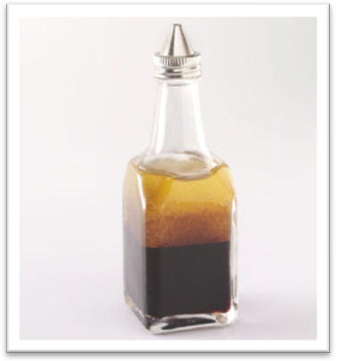
Directions:

- 1/8 cup extra virgin olive oil
- 1/8 cup Medicated Canna-Oil (Olive)
- ¾ cup balsamic vinegar
- ½ teaspoon dried oregano
- 2 teaspoons Dijon mustard
- 1 Clove minced garlic
- 1 pinch salt
- 1 pinch freshly ground black pepper

---------------------------------------------------------

Directions:

Combine the olive oil, vinegar, garlic, oregano, mustard, salt and pepper in a jar with a tight fitting lid. Shake well before serving. Store in the refrigerator. 2 tablespoons of dressing per serving.

Hummus of Your Dreams
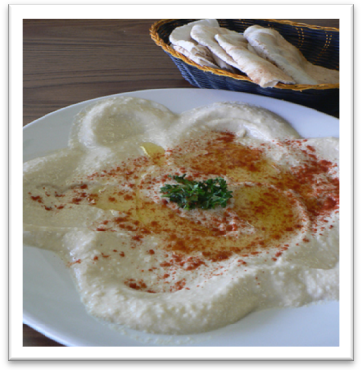
------------------------------------------------------------------------------------

Ingredients:

- 1 16 oz can of chickpeas or garbanzo beans
- 1/4 cup liquid from can of chickpeas
- 3-5 tablespoons lemon juice (depending on
taste)
- 1 1/2 tablespoons tahini
- 2 cloves garlic, crushed
- 1/2 teaspoon salt
- 2 tablespoons Canna-oil (Olive)

-------------------------------------------------------------------------------------------------------------

Directions:

Drain chickpeas and set aside liquid from can. Combine remaining ingredients in blender or food processor. Add 1/4 cup of liquid from chickpeas. Blend for 3-5 minutes on low until thoroughly mixed and smooth. Drizzle more Canna-oil (Olive) over the top if desired for additional potency. Contains 4-6 servings.

